**PROJECT REPORT**

ON

**“SERPENT BOT”**

**MINIPROJECT**

IN

**ROBTICS CLUB, BMSCE**



Department of Electronics and Communication Engineering

**B.M.S COLLEGE OF ENGINEERING**

(Autonomous College Affiliated to Visvesvaraya Technological University, Belgaum)

Bull Temple Road, Basavanagudi, Bangalore-560019

SUBMITTED BY:

**Team Slytherin**

**Adithya Adiga 1BM20IS010**

**Bhojraj Anand Kumbar 1BM19ME033**

**Bukkapatnam Meghana 1BM19EI017**

**Prachetha P Vasishta 1BM19EC105**

**Sree Suryadatta M Vadhoolas**  **1BM19EC161**

**Concept:**

The Serpent Bot is a mimic to the actual Snake which is capable of different modes of reptile locomotion. It is a wireless Wi-Fi controlled Bot whose motion is controlled by an Android Application. This simple Robotic model of a Snake has various use-case applications from a simple children toy to many Medical, Surveillance, Disaster management applications. Traditional Snake Bots locomote purely by changing the shape of their body, just like snakes. Many variants have been created which use wheels or treads for locomotion. No Snake Bots have been developed yet that can completely mimic the locomotion of real snakes, but researchers have been able to produce ways of moving that do not occur in nature. Hence this simple project’s objective is to mimic the near similarity to Slithering Motion.

**Components:**

The Components used for the Serpent Bot Model include various Structural and Electrical parts which are:

*NodeMCU:* The ESP8266 NodeMCU module is a built-in Wi-Fi Microcontroller used to control the Snake Motion according to the Commands received through Wi-Fi.

*SG90 Servo Motors:* The Servo Motor is a feedback-controlled Motor with 180° range of angle control. This is used to precisely control the Snakes’ joints for the appropriate snake motion according to the commands received.

*Lithium-ion batteries:* The rechargeable power source the Servo drivers, NodeMCU microcontroller and other modules on the Serpent Bot.

*Buck Regulators:* The DC-to-DC voltage converters with adjustable output to provide suitable power conversion from Li-ion batteries to the NodeMCU.

Other components such as the jumper wires, Battery casing, and components for testing purpose.

**Project Scope:**

There are few qualities that all Snake Bots share:

1. First, their small cross section to length ratio allows them to move into, and maneuverer through, tight spaces.
2. Second, their ability to change the shape of their body allows them to perform a wide range of behaviours, such as climbing stairs or tree trunks.
3. Additionally, many snake robots are constructed by chaining together a number of independent links. This redundancy makes them resistant to failure, because they can continue to operate even if parts of their body are destroyed.
4. The locomotive flexibility of Snake Bots makes them useful to operate in different terrestrial conditions.
5. Snake Bots can move on difficult geographical reliefs like mountain or hilly surface, deserts, rough terrains, wild forests underground and in narrow & difficult places like pipes, drains, gaps, holes, sewers and can climb trees, pipes, ladders, etc.
6. Snake is one of the creatures that exhibit excellent mobility in various terrains.
7. Snake robots most often have a high number of degrees of freedom (DOF) and they are able to locomote without using active wheels or legs.
8. In comparison to wheeled and legged mobile robots, the snake robots have high stability and good terrainability. The exterior can be completely sealed to keep dust and fluids out.

There are many applications for a Serpent like Bot due to its terrainability and wide range of motion behaviour, to mention a few are:

1. Rescue missions in earthquake area: The snake robot could crawl through destroyed buildings looking for people. It could also carry small amounts of food or water to people trapped by the building prior to the arrival of rescue personnel.
2. The snake robot can also be used for surveillance and maintenance of complex and possibly dangerous structures such as nuclear plants or pipelines.
3. In a city, it could inspect the sewer system looking for leaks or aiding fire-fighters.
4. NASA engineers are developing an intelligent robot snake that may help explore other worlds and perform construction tasks in space. The Snake Bot, able to independently dig in loose extra-terrestrial soil, smart enough to slither into cracks in a planet’s surface and capable of planning routes over or around obstacles.

**Hardware Architecture:**

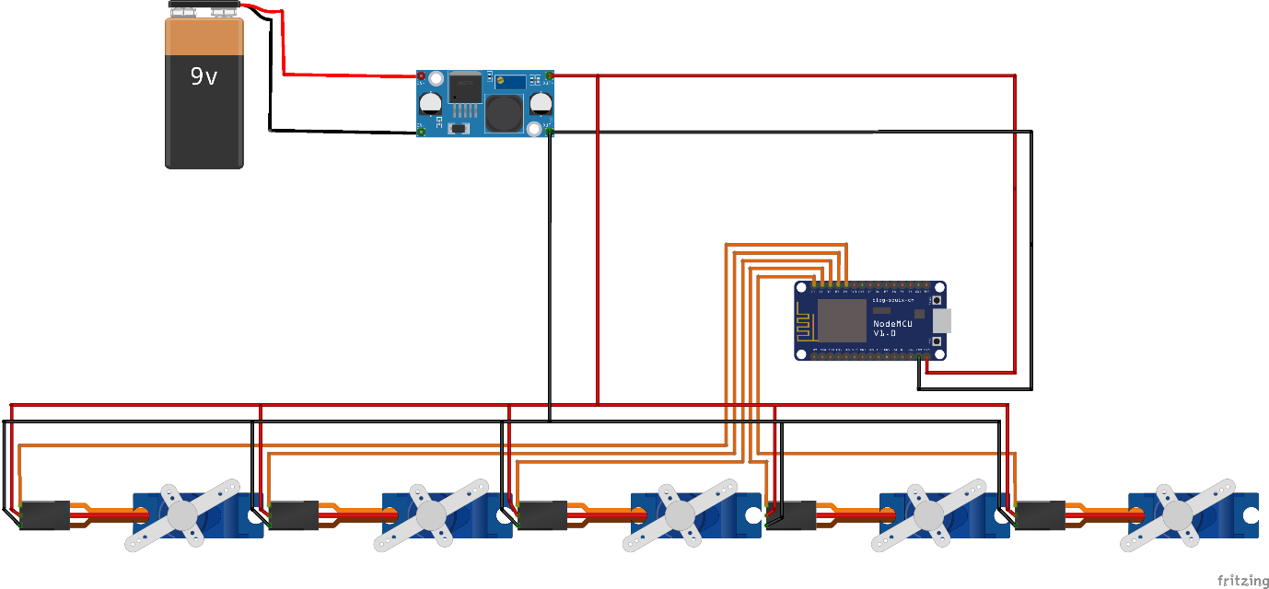

The hardware of snake bot primarily consists of building blocks (in this case 5), motion between which is controlled by the Servos (SG90). The Servo motors are driven by external 5V power supply from the LM2596 buck regulator to provide adequate current to the motors. The angle of motion for each Servo is calculated and controlled via NodeMCU using Servo Library. On the top, the Wi-Fi application communicates with the NodeMCU to provide motion commands using in built ESP8266 Wi-Fi Library.

Connections:

Power: 5V supply to be given to NodeMCU and 5-7V for each SG90 Servo motor. Hence, few Lithium-Ion Batteries is used along with LM2596 Buck Regulator.

Servo Motor: It consists of Power, Ground and Control pins, where the Power and GND pins are connected to LM2596 regulated supply and the Control pins to NodeMCU GPIOs.

**Software Architecture:**

Start

While 1

If command received (Wi-Fi)

no

yes

Command-value: f/b/l/r/s?

no

End

Write Servo angles via I2C: Move according to command

Calculate Angles for Servos: forward/backward/right/left/stop